**Facial Recognition using OpenCV**

**1. Introduction**

Facial recognition technology identifies or verifies a person by analyzing facial features. It is a biometric technique widely used for security and authentication purposes. In this project, we utilize **OpenCV**, a popular open-source computer vision library, to implement a real-time facial recognition system. This system can recognize individuals by comparing the features of a live face to a pre-trained dataset.

**2. Prerequisites and Libraries**

For this project, the following tools and libraries are necessary:

* **Python**: The programming language used.
* **OpenCV**: Used for face detection and image processing.
* **Numpy**: Handles arrays and matrix operations.
* **Dlib**: Provides facial landmark detection and face recognition features.
* **face_recognition**: A library built on top of Dlib for easy face recognition.

These tools allow for efficient processing and recognition of facial features using deep learning algorithms.

**3. Dataset Preparation**

For effective facial recognition, you need a dataset containing multiple images of each person. These images should capture different angles, expressions, and lighting conditions to improve recognition accuracy.

Steps involved:

* Capture or collect several images of each individual.
* Organize the images into folders, each representing a different person.
* Ensure the images have clear views of the person’s face for accurate detection.

Preprocessing the dataset, such as resizing images and face alignment, may enhance the performance of the system.

**4. Steps in Facial Recognition**

**4.1 Face Detection**

The first step is detecting faces within an image or video stream. OpenCV’s pre-trained Haar cascades or other methods can identify face regions by detecting key features like the eyes, nose, and mouth.

**4.2 Face Alignment**

After detecting the face, the next step is to align it. Face alignment ensures that the face is positioned in a standardized format, making it easier to extract features and recognize the face correctly.

**4.3 Face Encoding**

Face encoding converts each face into a numerical representation (often a vector). This encoding process extracts and stores unique facial features. These numerical values represent various characteristics of the face and can be compared later for recognition.

**4.4 Face Matching**

Matching is the final step where the system compares the newly detected face’s encoding to previously stored encodings. If the features of the new face match those in the database, the system identifies the person. A similarity threshold is set to determine the degree of match between faces.

**5. Implementation Process**

The system processes video input in real time, detecting and recognizing faces continuously. The typical process flow involves:

1. **Input**: The system captures images from a live webcam or video stream.
2. **Face Detection**: It detects faces in the frame and isolates them for further processing.
3. **Feature Extraction**: It encodes the facial features of the detected faces.
4. **Recognition**: The system matches the extracted features with known faces stored in the dataset.
5. **Display**: The recognized faces are labeled with their names or IDs on the video feed.

The recognition model may rely on deep learning techniques like CNNs (Convolutional Neural Networks) to enhance accuracy in feature extraction.

1. **Diagram**

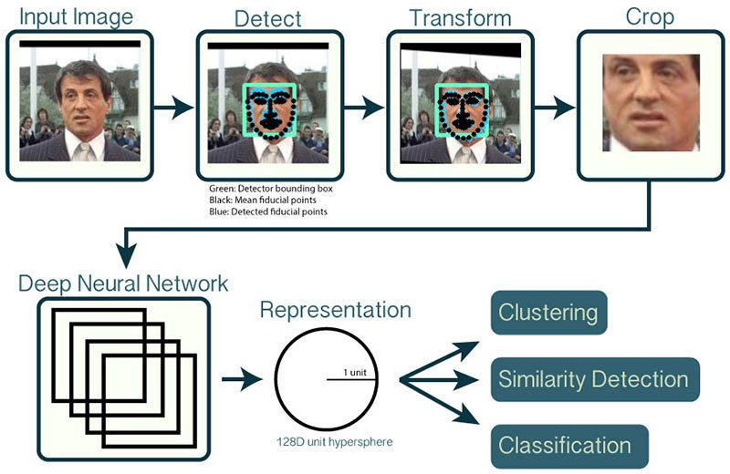

1. **Advantages of Facial Recognition**
2. **Enhanced Security**:
   * Facial recognition can improve security in various environments such as airports, public places, and secure facilities. It can help identify individuals on watchlists or those engaging in suspicious activities, contributing to public safety.
3. **Contactless and Convenient**:
   * Unlike fingerprint or password-based systems, facial recognition is a contactless authentication method. It allows people to unlock devices, access accounts, or enter secure areas without physical interaction, which is especially useful during pandemics or in high-traffic areas.
4. **Speed and Efficiency**:
   * Modern facial recognition systems can quickly scan and match faces, making it an efficient tool for identifying people in real-time. It can streamline processes such as airport check-ins, where travelers can pass through checkpoints with less delay.
5. **Reduced Fraud**:
   * Facial recognition can help reduce identity theft or impersonation in areas like banking, online transactions, and law enforcement by verifying that the person accessing a system is the rightful user.
6. **Improved User Experience**:
   * Facial recognition is increasingly used in smartphones, laptops, and social media platforms for personalized experiences (e.g., unlocking phones, tagging people in photos). It enhances user convenience and interaction with technology.
7. **Disadvantages of Facial Recognition**
8. **Privacy Concerns**:
   * One of the most significant drawbacks is the potential violation of privacy. Continuous surveillance and face-tracking in public spaces or online platforms can lead to concerns about the collection and use of personal data without consent.
9. **Accuracy Issues**:
   * Facial recognition systems can sometimes struggle with accuracy, especially under poor lighting conditions, certain angles, or when dealing with individuals of different ethnic backgrounds. This can lead to **false positives** (incorrectly identifying someone) or **false negatives** (failing to identify the right person).
10. **Potential for Misuse**:
    * In authoritarian regimes or surveillance-heavy environments, facial recognition technology can be misused to monitor and control citizens, stifling freedom of speech and movement.
11. **Bias and Discrimination**:
    * Studies have shown that some facial recognition algorithms may have inherent biases, particularly in recognizing individuals with darker skin tones or women. This bias can lead to discrimination and unjust outcomes, especially in law enforcement.
12. **Data Security Risks**:
    * Like other forms of digital data, facial recognition data can be hacked or leaked. If a facial recognition database is compromised, it could lead to serious security risks and identity theft, as facial features cannot be changed like a password.

**9. Results**

In the experiment, the system was able to detect and recognize faces with a high degree of accuracy in real-time video streams. The system performance was evaluated based on its ability to match the correct person with the stored dataset. Some factors, such as lighting and face angles, affected recognition accuracy, but overall, the system demonstrated reliable performance.

**10. Applications of Facial Recognition**

Facial recognition has a wide range of applications, including:

* **Security and Surveillance**: Used for identifying individuals in public spaces or restricted areas.
* **Authentication Systems**: Allows biometric authentication for unlocking devices or systems.
* **Attendance Systems**: Automates attendance marking in schools, workplaces, and events.
* **Retail and Marketing**: Helps retailers to provide personalized services based on customer recognition.

**11. Conclusion**

Facial recognition using OpenCV provides a robust solution for real-time identification of individuals. By leveraging deep learning algorithms and image processing techniques, this system can be applied in various industries for security, authentication, and automation. However, the accuracy of recognition can be affected by environmental factors like lighting and facial angles, which require further improvements in feature extraction and matching algorithms.